Hi Lucas,

I have chosen the approach whatever Stephen have chosen. I am able to insert the file attachment data to the data entities and retrieve it back. Steps below.

1. Create Master and Child entities with some relationship
2. I created 2 entities ‘DemoParent’ and ‘DemoChild’ which are related by ‘StudentId’. Primary table is the Student Table with just the student name and the child table is the table with 2 fields, Course Name and File Url.

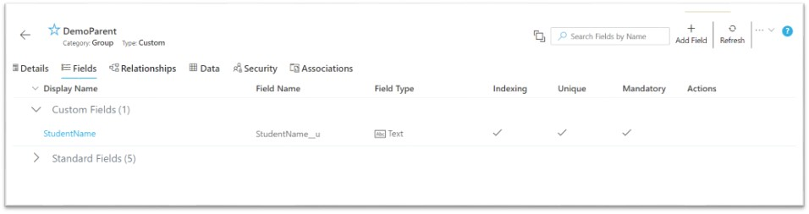

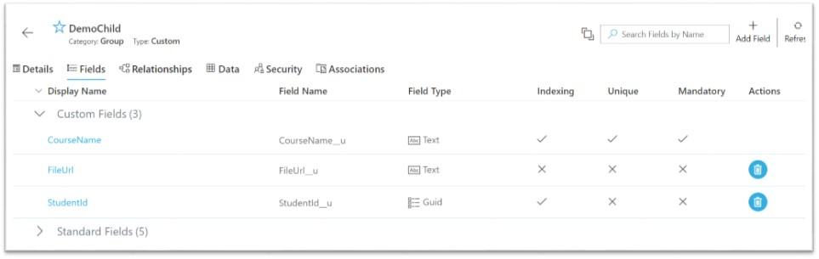

**Relationship**

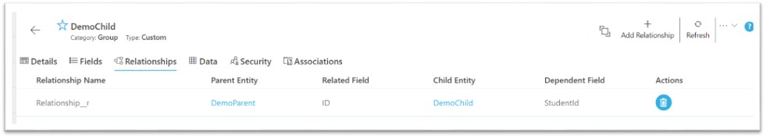

1. I created a data entity based process which has an upload control inside the submit form as shown below.

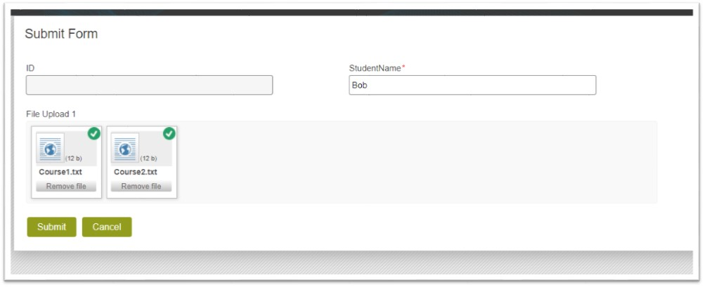

1. On submit, the data is added from both main field and upload fields. For main field (StudentName only in our case), it is bound through data entity. But for the upload field, I have used ‘Upsert Multiple Records’ shape where I have mapped the file attachment control metadata.

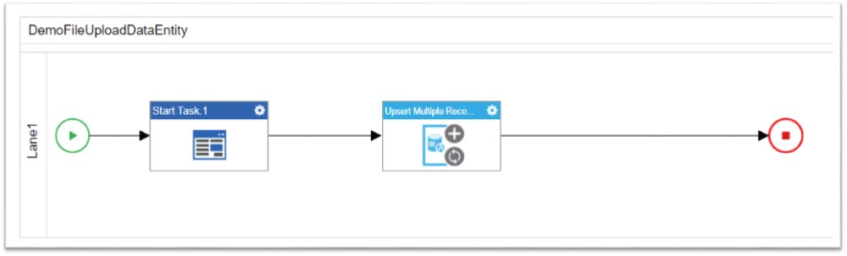

1. Data available in data entities as shown below.

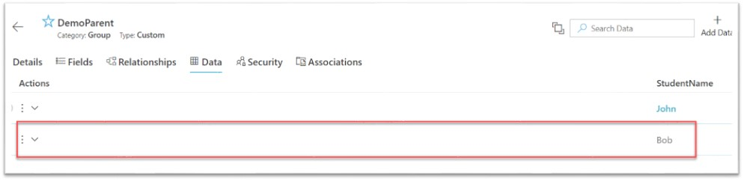

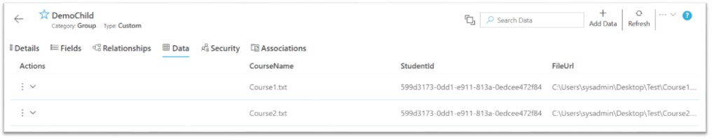

1. I then created a form based process to view the forms as below.

All Records

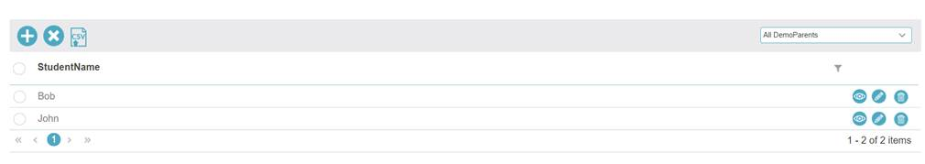

On view of the record, it show the detailed information which includes file attachments. You can chose not to show the StudentId and ID column on the subform.

There is no configuration to hide the ‘Edit’ button. We may need to look for some JS. Will let you know on this. Please try this and let me know if you have any questions.

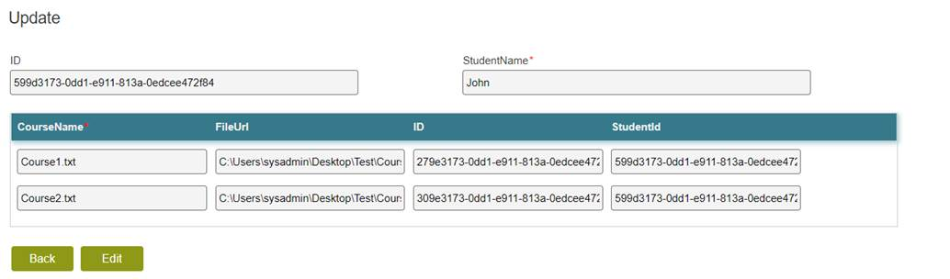

Thanks,

Vinayaka